**Backing up Databases in Oracle**

A data backup is a copy of the data that we keep so as to restore our original data in the case of events such as data loss. Needless to say, if we are running a business or even if we have some data on our computer that we wouldn’t want to lose, taking the backup of the data is considered the best practice. Backup is key to providing a secure and reliable database environment.

Now, data loss can be caused due to various reasons, which are why taking backups becomes so important. Some of the reasons for data loss are:

* Accidentally misplacing or deleting data
* Virus attacks
* Hardware crashes
* Moving data from one system to another, and so on.

Now that we understood what a backup is and why do we need it, let’s see how Oracle Database, one of the biggest database management systems, helps in handling data backups.

**Backup Solutions in Oracle**

There are basically two ways to perform a data backup in Oracle:

* **Oracle Recovery Manager**:

Oracle provides a powerful utility to back up and restore databases, which is known as Oracle Recovery Manager (RMAN). We can use RMAN to back up databases as a complete backup or incremental backup. Since RMAN is a feature of the Oracle Database server, there is no need to separately install it.

* **User-managed Backup and Recovery**:

Other than RMAN, Oracle also supports user-managed backup and recovery, where users can implement the backup and recovery of databases using a mixture of host operating commands and  SQL Plus commands, i.e., the users have to use different commands for different OS. In user-managed backup and recovery, a user will be scheduling how and when the backup has to be implemented.

When comparing both backup and recovery solutions, RMAN is most recommended since it offers one common interface for implementing backup across all different host operating systems, which makes it very user-friendly.

[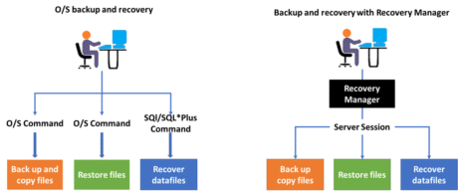](https://intellipaat.com/mediaFiles/2015/09/Picture1-1.png)  
System Database Administrators can set up RMAN database backups, as well as schedule them, for multiple databases. In this section, we will learn how to take backups, how to recover files, databases, etc., and more in Oracle.

Let’s start off by understanding how Oracle strategizes all backups and recovery processes.

**Backup Strategies**

Oracle Database Configuration Assistant (DBCA) sets up RMAN backup and maintenance plans, using Oracle Enterprise Manager (OEM). OEM is a set of web-based tools used to manage software and hardware that are produced by Oracle Corporation.

To take the RMAN backup of a database, we create and save copies of the database to disk and tape with certain retention policies. A duplicate or copy database created by Recovery Manager, i.e., RMAN, is mostly used to test backup and recovery procedures before implementing them on the real database and eventually the RMAN backups are stored.

As shown in the following image, RMAN connects to the source database, the one that needs to be backed up. RMAN then copies the database over a network to an auxiliary instance, creating a duplicate database, which is connected to RMAN.

[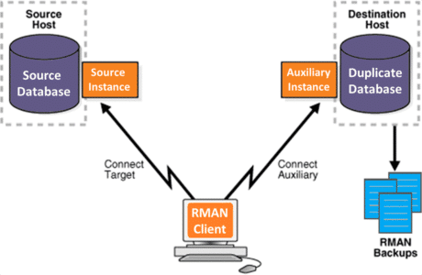](https://intellipaat.com/mediaFiles/2015/09/Picture2.png)  
This is how the Recovery Manager works. However, before we can start backing up a data base, we will have to configure our Recovery Manager. Let’s now see how to configure RMAN.

**RMAN Configuration for Backups**

RMAN is installed with the Oracle software and placed in the ORACLE_HOME/bin/ directory. RMAN uses either a catalog to track and manage backups or the control file of the database for this purpose.

To configure RMAN, we have to create a user to be the catalog owner and grant this user a quota on the table space where the schema is going to live, as well as the RECOVERY_CATALOG_OWNER role.